**Swift Workshop – Downloading Instructions (Xcode and images) & Cheat Sheet**

* pre-requisite: Mac computer

1) Open App Store on Mac (shortcut: command + space and type App Store)

2) Search for Xcode:

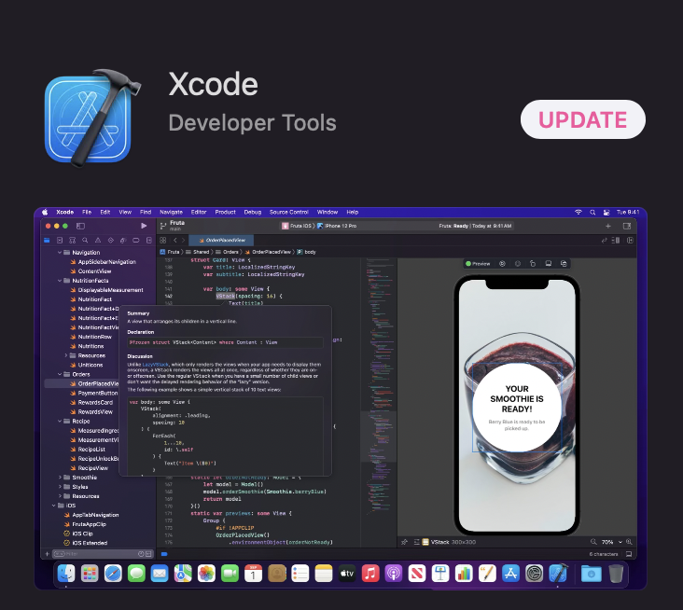

* Mine says UPDATE yours should say GET or INSTALL

3) Make sure you have sufficient space on your computer (Xcode is 12.6 GB)

* To check how much available storage you have on your Mac, click on the apple in the top left corner of the screen at any time:

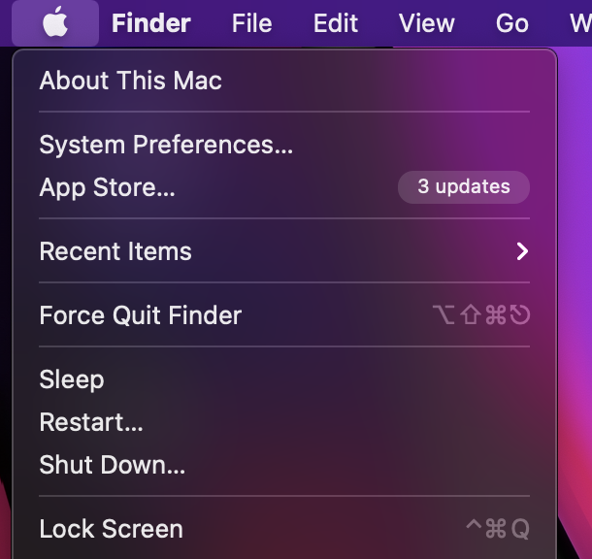

* Click “About This Mac”
* Click “Storage” in the top menu (middle option) and see how many GB you have available
  + Delete unnecessary files/apps to clear up space if needed

4) Download Xcode

* This can be a long process since it is a large app, so give it time and be patient!

5) Downloading images for the project that we will do during the workshop:

* Go to this link: <https://www.dropbox.com/sh/7aopencivoiegz4/AADFtW9ipj7EJjEmtb5gmshQa/Lesson%2005?dl=0&preview=Image+Assets.zip&subfolder_nav_tracking=1>
* Click Download on the top left corner of the page (visual below)

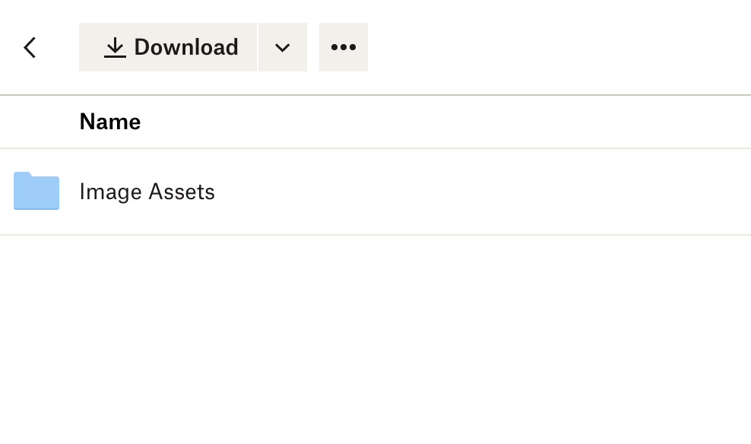

5) **Attend Swift workshop at 5:15 PM in Room 107!**

6) Here’s a helpful cheat sheet:

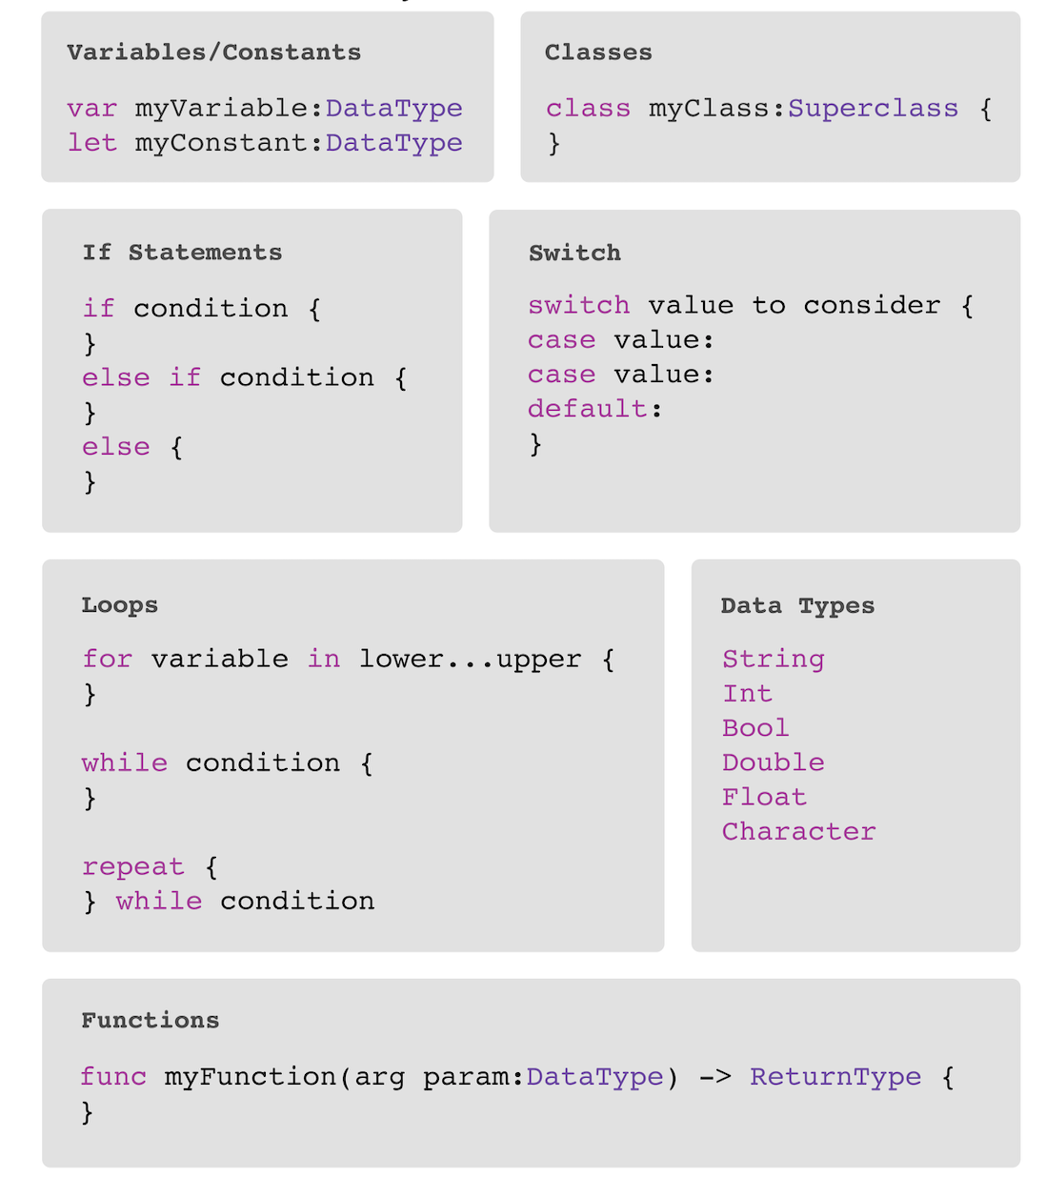

7) For future learning, I find a great resource to be: [How To Make An App for Beginners 2021 / SwiftUI - Lesson 1](https://www.youtube.com/watch?v=yOYnXoFvmj4&list=PLMRqhzcHGw1YqPh-ggQHJPAUxdHov_uNJ) AKA Code with Chris on YouTube! (You can also find the card game challenge on here too for further clarification on the project we worked through in the workshop) 😊

